Project Report Template

# 1.INTRODUCTION

## Overview

The project aim is to provide real-time knowledge for all the students who have basic knowledge of Salesforce and Looking for a real-time project.

## Purpose

This project will also help to those professionals who are in cross-

Tecnology and wanted to switch to Salesforce with the help of this project they will gain

Knowledge and can include into their resume as well.

# 2.Problem Definition & Design Thinking

## 2.1 Empathy Map

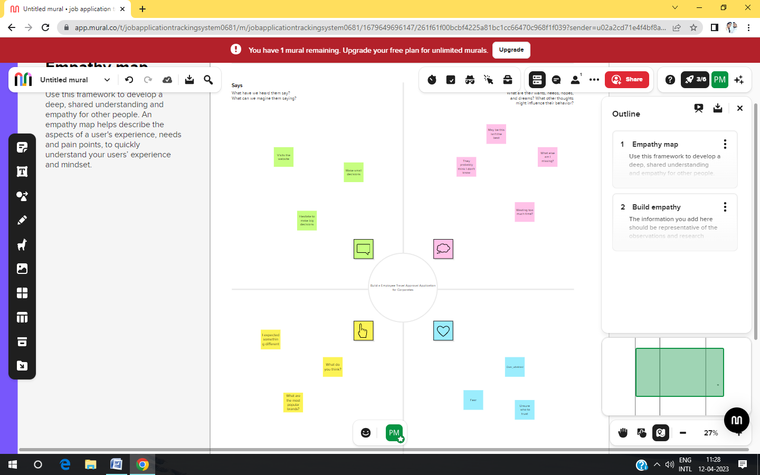

## 2.2 Ideation & Brainstorming map screenshot

## 

|  |
| --- |
|  |

## 

# 3. RESULT

## 3.1 Data Modal

|  |  |
| --- | --- |
| Object name | Fields in the object |
| Department | |  |  | | --- | --- | | Field label | Data type | | Department | Auto number | |  |  | |
| Travel approval | |  |  | | --- | --- | | Field label | Data type | | Travel approval | Auto nmber | |  |  | |
| Expense item | |  |  | | --- | --- | | Field label | Data type | | Expanse item | Auto number | |  |  | |

## 3.2 Activity & Screenshot

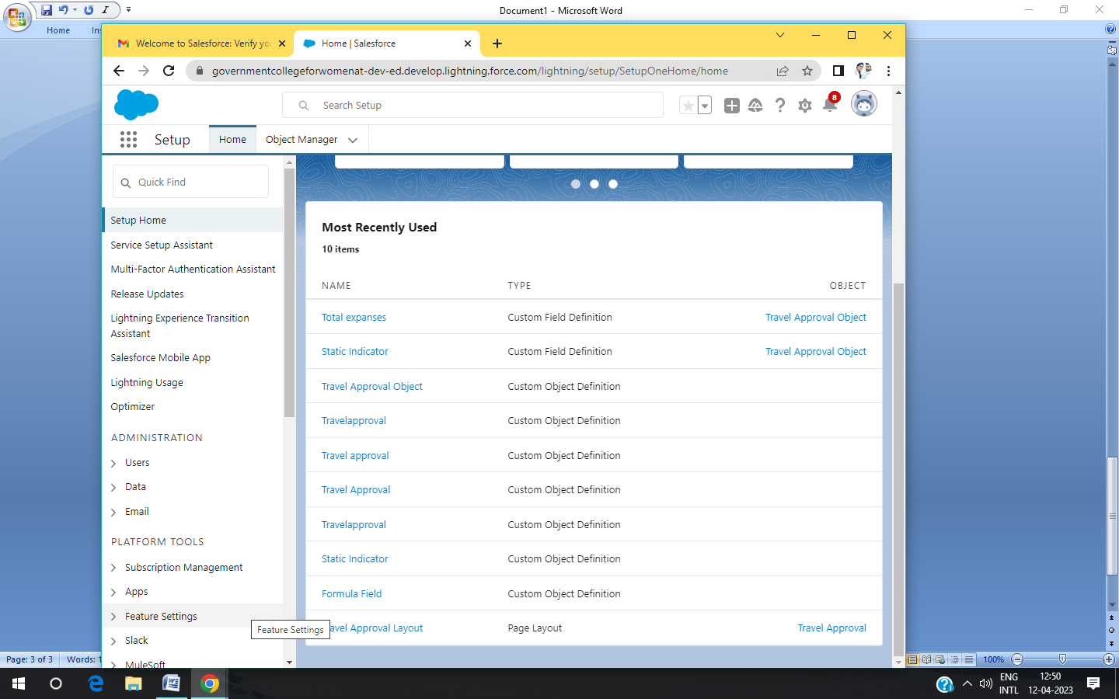

# 4. Advantages & Disadvantages

This project will also help to those professional who are in cross-technology and

Wanted to switch to salesforce with the this project they will gain knowledge and canincluded into their reume as well.

None of disadvantages.

# 5.Applications

Salesforse has everything you need to run your business from anywhere. Using standard products and features, you can manage relationships with prospects and customers, collaborate and engage wit employees and partners, and store your data securely in the cloud.

# 6. Conclusion

It is very useful and experience in every system.Salceforce is your customer success platform, desingned to help you sell,service, market, analyze, and connected with your customer.

# 7.Future scope

Expands your skills & experiences across all salesforce recognized industries.

# 8.Trailhead Profile public URL

## Team Lead – trailblazer.me/id/bbaskar12

Team member 1- trailblazer.me/id/mabarna

Team member2- trailblazer.me/id/niths43

Team member3 - trailblazer.me/id/shark114